FDLCA LAB

Practical 7 & 8

MIPS assembly level language

Practical 7:

Q1) ADD and SUB two user imputed numbers

**CODE:**

.text

main:

li $v0,5

syscall

li $v1,5

syscall

move $t0,$v0

move $t1,$v1

li $v0,4

la $a0,msg1

syscall

add $t2,$t0,$t1

li $v0,1

move $a0,$t2

syscall

li $v0,4

la $a0,msg2

syscall

sub $t3,$t0,$t1

li $v0,1

move $a0,$t3

syscall

exit:

li $v0,10

syscall

.data

msg1: .asciiz "sum is : "

msg2: .asciiz "dif is : "

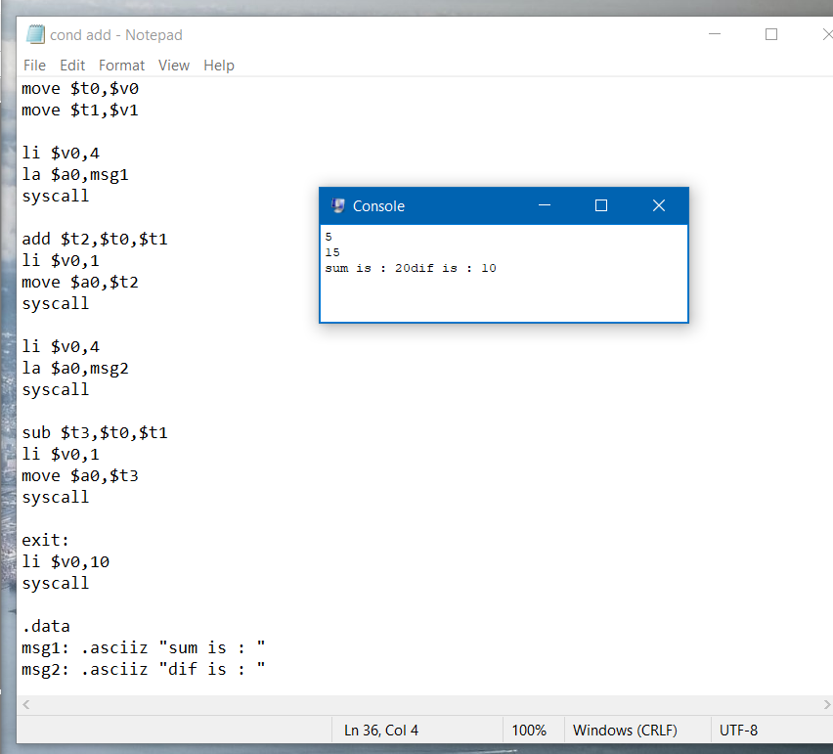

Practical 8

Q1) Largest of three user inputted numbers.

**CODE:**

.text

main:

li $v0,5

move $t0,$v0

syscall

li $v0,5

move $t1,$v0

syscall

li $v0,5

move $t2,$v0

syscall

ble $t0,$t1,cond1else

ble $t0,$t2,cond2else

li $v0,4

la $a0,msg1

syscall

li $v0,10

syscall

cond1else:

ble $t1,$t2,cond2else

li $v0,4

la $a0,msg2

syscall

li $v0,10

syscall

cond2else:

li $v0,4

la $a0,msg3

syscall

li $v0,10

syscall

.data

msg1: .asciiz "NO. 1 is largest"

msg2: .asciiz "NO. 2 is largest"

msg3: .asciiz "NO. 3 is largest"

